* What are the requirements for a 'Rich image'?
  + Structures
  + Processes
  + Climate
  + People
  + Issues expressed by people
  + Conflict
* On the basis of CATWOE, the students must prepare a 'Rich picture' for the semester project.
* Delivery: The 'Rich picture' is delivered and the process is commented on.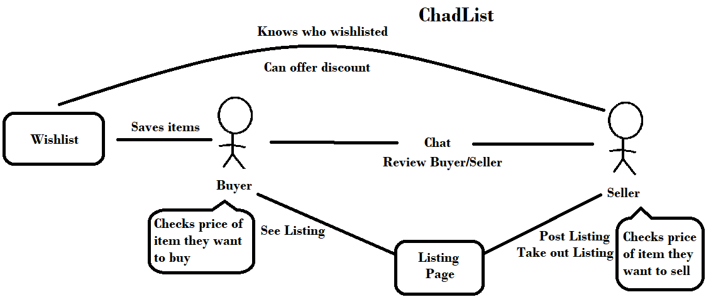

This rich picture is an illustration of our SEP3 project idea. ChadList stands for a second-hand marketplace which should help with waste. The idea is simple, the only and most important actors are the Sellers and the Buyers, which will actually run the whole system. A seller will be posting an item, containing all the necessary information about the item. The posted item will then get into a Listing Page. The Buyers are able to look through the Listing Page, see the items, talk to the Seller and Wishlist the item. The Seller can see who wishlisted their item and can make discounts for the Buyer that wishlisted the item. A Buyer and a Seller can comment on each other, which will affect the Buyer’s/Seller’s reliance.